1. The frontend app has 3 main pages. Home, Date Range, and Dashboard. By default, the Dashboard page looks like below:

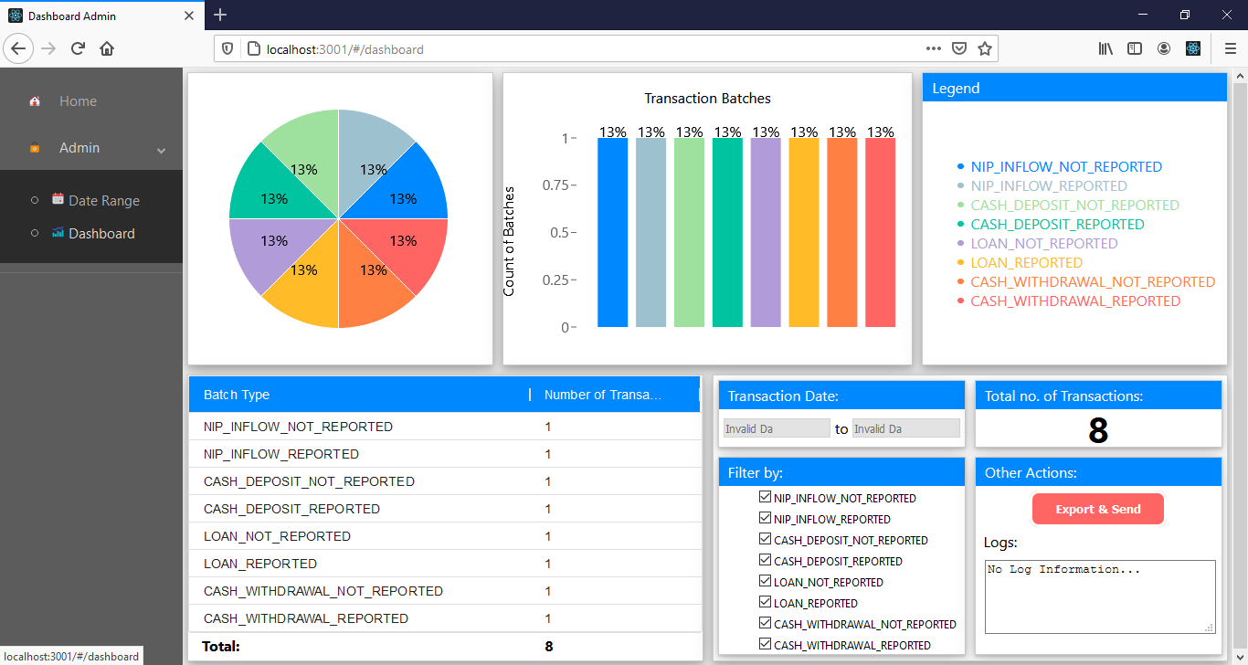

2. To load data, go to the Date Range page and set the Start and End date fields. An error will be shown if any of the following aren’t satisfied:

2.a Either of the Start Date or the End Date fields are blank.

2.b The End Date field is set before the Start Date field.

Set the Start and End date fields properly, and click on Run Report. A prompt will be displayed if the operation was successful, like below:  
  
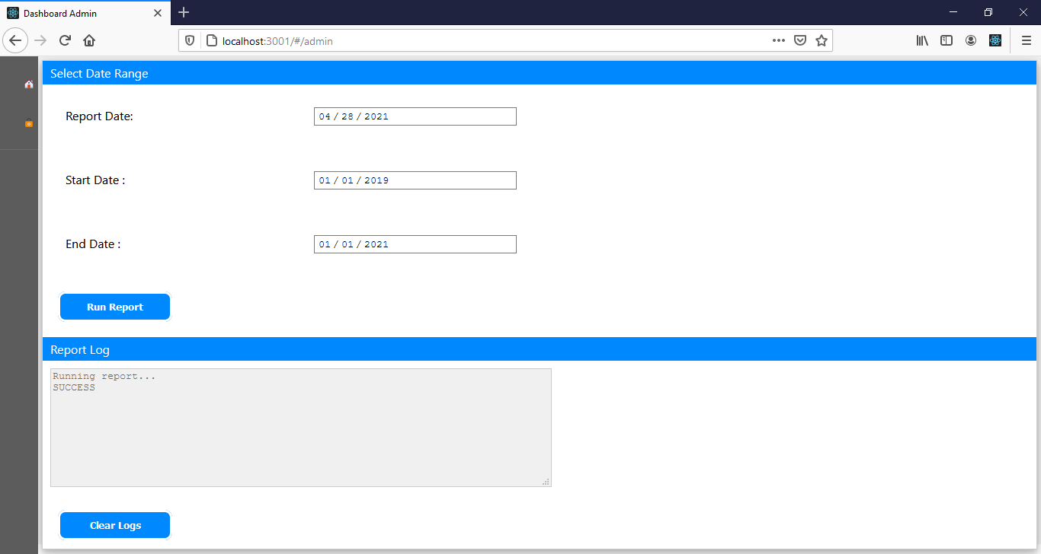

If at any time the app is stuck at “Running Report…” and not displaying the “SUCCESS” message, make sure that the back-end app is running. If it is and it appears to be stuck, just try to go to the CMD prompt where the back-end app is running and hit “CTRL-C” to cancel whatever process it is stuck in”. Worst case scenario, you may need to restart the back-end app.

3. The Dashboard page should now load the data pulled from Date Range page, like below:  
  
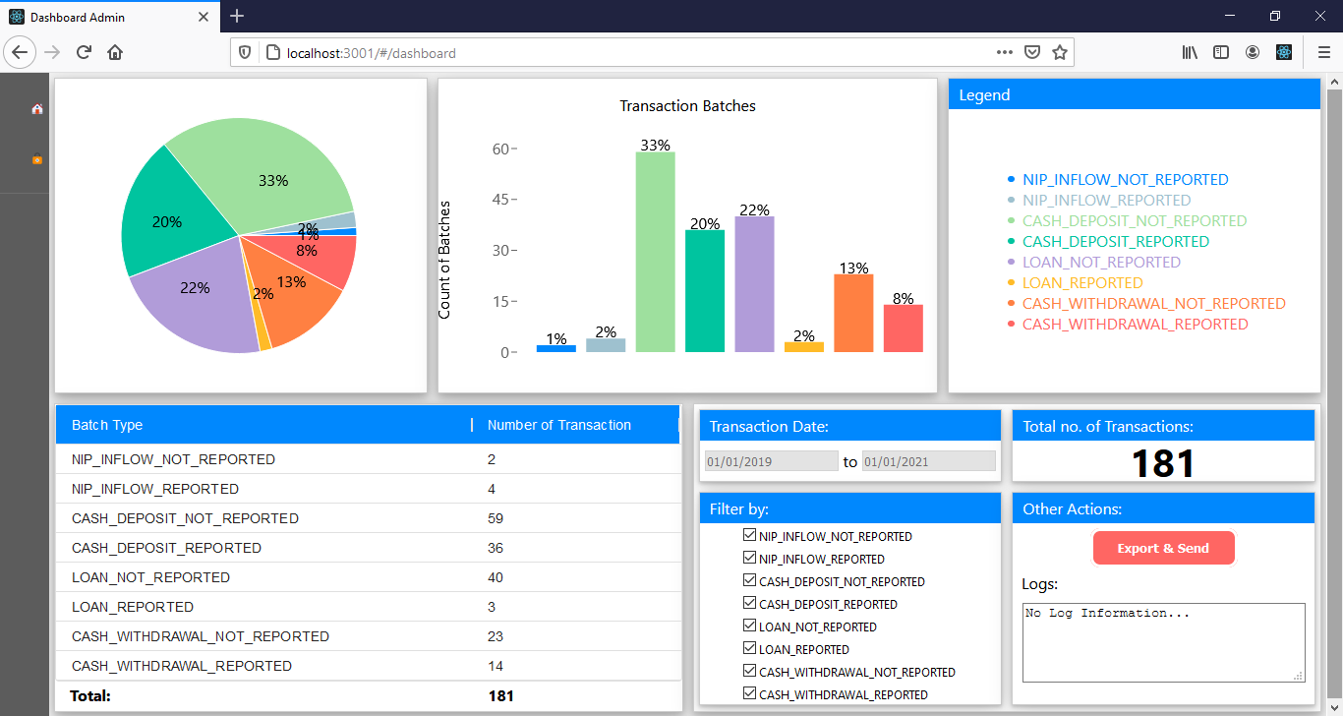

4. To filter the displayed data, check and uncheck the check boxes in the “Filter By” box. This will automatically adjust the displayed data in the pie chart, the bar graph, the table on the lower left side of the screen, and all displayed total transaction amounts. For instance, below is the result of unchecking half of the checkboxes:

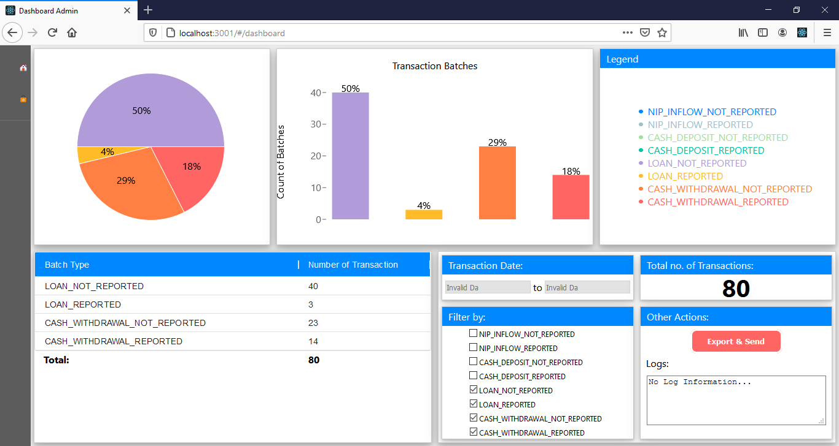

5. To save a snapshot of the display, click on “Export and Send”. A download prompt should appear, like below:  
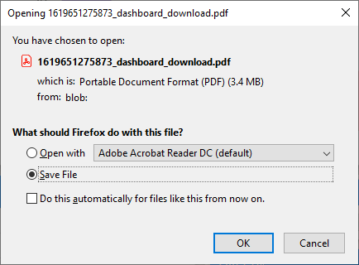

Open the downloaded file to view a snapshot of the displayed page.